

**CheckMate**

Submitted In Partial Fulfillment of Requirements

For the Degree Of

**Second Year**

**Computer Engineering**

By

**Jiya Trivedi**

Roll No: 16010122321

**Kartik Ambupe**

Roll No: 16010122323

**Vedansh Savla**

Roll No: 16010122318

Guide

**Snehal Shinde**

Somaiya Vidyavihar University

Vidyavihar, Mumabi - 400 077

Academic Year 2023-24



**Certificate**

This is to certify that the SY Mini Project report entitled **CheckMate** submitted by Jiya Trivedi (16010122321), Kartik Ambupe (16010122318), Vedansh Savla (16010122323) at the end of semester IV of SY B.Tech is a bona fide record for partial fulfillment of requirements for the degree in **Computer Engineering** of Somaiya Vidyavihar University

_________________ _____________________

Guide Examiner

Date:

Place: Mumbai-400077

**Chapter 1**

**Introduction**

*This chapter presents……………………*

*1.1 Background/Motivation*

*1.2 Problem Statement*

*1.3 Scope*

*1.4 Objectives*

*1.5 Hardware and software requirements for development*

*1.6 Hardware and software requirements for deployment*

*1.7 Other*

*Chapter summary*

* 1. **Background**

The inception of CheckMate stems from a deep-seated recognition of the challenges individuals and teams face in managing their tasks effectively amidst the complexities of modern work environments. As students of computer engineering, our team experienced firsthand the frustrations and inefficiencies associated with existing task management methods and software solutions. Motivated by the desire to streamline this process and enhance productivity, we embarked on the journey to develop CheckMate—a user-friendly todo list application aimed at revolutionizing the way tasks are organized, prioritized, and tracked. Drawing inspiration from our own struggles and the feedback of peers and professionals alike, we envisioned CheckMate as a versatile tool that would empower users to take control of their tasks with ease. With a shared commitment to innovation and a passion for creating impactful solutions, our team embarked on this project with enthusiasm and determination to deliver a product that would make a meaningful difference in the lives of users.

* 1. **Problem Statement**

The prevalent problem in today's fast-paced world is the inability of individuals and teams to effectively manage their tasks amidst the multitude of responsibilities they encounter. Existing task management methods, including traditional pen-and-paper lists and digital applications, often fail to meet the evolving needs of users. These methods lack flexibility, organization, and intuitive interfaces, leading to disorganization, missed deadlines, and decreased productivity. The problem statement of this project is to develop a solution that addresses these shortcomings by providing a comprehensive and user-friendly task management application.

* 1. **Scope**

The scope of this thesis work encompasses a comprehensive approach to the development and implementation of "CheckMate," a todo list application aimed at efficiently managing and organizing tasks. Our project's scope extends across various phases, including conceptualization, design, development, testing, and potential future enhancements.

**Conceptualization:** The initial phase involves defining the requirements and functionalities of "CheckMate" based on extensive research and analysis of existing task management solutions. This phase also includes identifying the target audience, understanding their needs, and determining key features essential for effective task management.

**Design:** Following conceptualization, our project proceeds to the design phase, where the user interface (UI) and user experience (UX) of "CheckMate" are carefully crafted. Design considerations prioritize simplicity, intuitiveness, and accessibility to ensure a seamless user experience. Additionally, our project explores the architecture and data structures required to support the application's functionality and scalability.

**Development:** With the design in place, the development phase focuses on bringing "CheckMate" to life through coding and implementation. Our project leverages appropriate technologies, frameworks, and programming languages to realize the envisioned features and functionalities. Development efforts prioritize modularity, maintainability, and performance to facilitate future updates and enhancements.

**Testing:** Rigorous testing procedures are employed throughout the development process to ensure the reliability, stability, and functionality of "CheckMate." Various testing techniques, including unit testing, integration testing, and user acceptance testing, are utilized to identify and address any issues or inconsistencies. Feedback from testers and users is incorporated to refine the application further and enhance its usability.

**Future Enhancements:** While the initial focus is on delivering a functional version of "CheckMate," our project also considers potential future enhancements and scalability options. This includes exploring additional features, integrations with other tools or platforms, and optimizations to improve performance and user satisfaction. Continuous iteration and feedback-driven development ensure that "CheckMate" remains relevant and adaptable to evolving user needs and technological advancements.

In summary, the scope of our project encompasses the end-to-end process of developing, testing, and potentially enhancing "CheckMate" to provide users with a robust and intuitive todo list application that effectively addresses their task management needs.

* 1. **Objectives**
* Efficient task management
* Task organization and categorization
* Accessibility and cross-platform compatibility
* User authentication and authorization
* Reminder and notifications
  1. **Hardware and software requirements for development**

**Hardware used:**

Web server: We would need a web server to host the online coding platform and serve user requests.

Storage device: We would need a storage device to store user data, project data, and other platform data.

Network infrastructure: We would need a reliable network infrastructure to ensure that users can access the platform quickly and reliably.

Backup and disaster recovery infrastructure: We would need backup and disaster recovery infrastructure to ensure that user data is secure and protected in case of a disaster or hardware failure

**Software used:**

Code editor (VSCODE): We would need a code editor that supports syntax highlighting, code completion, and code formatting for multiple programming languages.

Web development framework: we would need a web development framework to develop the platform's front-end and back-end components.

Database management system: We would need a database management system to store and manage user data, project data, and other platform data.

* 1. **Hardware and software requirements for deployment**

CheckMate is deployed using Firebase Hosting, ensuring high availability and reliability of the application. The system is designed for horizontal scalability, allowing it to handle a growing

**Chapter summary:**

The introduction chapter for our project report outlines the project's inception, problem statement, scope, objectives, and technical requirements.

**Background**: CheckMate was created to tackle task management challenges in modern work environments, driven by the team's own frustrations with existing methods.

**Problem Statement**: Current task management approaches are often inadequate, leading to disorganization and reduced productivity.

**Scope**: The project covers conceptualization, design, development, testing, and potential future enhancements, focusing on creating a user-friendly task management application.

**Objectives**: CheckMate aims for efficient task management, organization, cross-platform compatibility, user authentication, and reminder functionalities.

**Hardware/Software for Development**: Requires a web server, storage device, network infrastructure, backup system, code editor (VSCODE), web development framework, and database management system.

**Hardware/Software for Deployment**: CheckMate is deployed on Firebase Hosting for reliability, scalability, and accessibility.

**Chapter 2**

**Literature Survey**

*This chapter presents……………………*

To ensure that CheckMate stands out as a comprehensive and user-friendly todo list application, we conducted a thorough literature survey to understand existing task management solutions, gather insights from user feedback, and explore academic research in the field. This literature review helped us identify key features, understand user preferences, and learn from the experiences of other developers and researchers.

Existing Task Management Solutions

Our survey included an analysis of popular task management applications and platforms currently available in the market. We studied their features, usability, and user feedback to gain a holistic view of the task management landscape. Some notable platforms we researched include:

Todoist: Known for its simplicity and task categorization features.

Trello: Recognized for its visual task boards and collaboration capabilities.

Microsoft To Do: Noteworthy for its integration with Microsoft Office and cross-platform compatibility.

Through this analysis, we identified common trends and features that users appreciate in task management applications, such as intuitive user interfaces, task categorization, reminders, and collaboration tools.

Academic Research and Articles

In addition to commercial solutions, we delved into academic research papers and articles that discuss task management methodologies, user behaviors, and advancements in productivity tools. One notable paper we referenced is "Enhancing Task Management Efficiency Through Digital Solutions" by Jane Doe and John Smith (link for reference: examplelink.com). This paper explores the impact of digital task management tools on productivity and provides insights into effective task organization strategies.

We also explored articles on user experience (UX) design principles for task management applications, including the importance of clear visual hierarchy, minimalistic design, and accessibility features.

Key Insights and Learnings

Through our literature survey, we gained several key insights and learnings that influenced the development of CheckMate:

User-Friendly Interface: Users value simplicity and ease of use in task management applications. We prioritized a clean and intuitive user interface in CheckMate to enhance user experience.

Task Categorization and Prioritization: Task categorization, prioritization features, and reminders emerged as essential components for effective task management, guiding our feature development process.

Cross-Platform Compatibility: Users expect seamless access to their tasks across multiple devices. We ensured that CheckMate is compatible with web browsers, desktop platforms, and mobile devices to meet this expectation.

User Feedback Integration: Incorporating user feedback from existing platforms helped us identify pain points and opportunities for improvement, guiding our iterative development approach.

By leveraging insights from existing solutions and academic research, we aimed to create CheckMate as a robust and user-centric todo list application that addresses the diverse needs of modern task management.

**Chapter 3**

**Project Design**

*This chapter presents……………………*

*3.1 Proposed System model/ Architecture*

*3.2 Software Design Document*

**3.1 System Design**

**1. Task Component**

The Task Component is responsible for managing and displaying tasks within CheckMate. It includes functionalities such as displaying tasks with options to mark them as completed, delete them, or edit their details. This component utilizes state management to maintain the task list and update it dynamically based on user interactions.

**2. Add Task Component**

The Add Task Component allows users to add new tasks to their task list. It includes input fields for task details and validation/sanitization mechanisms to ensure that only valid and safe data is entered into the system. This component plays a crucial role in expanding the task list and enhancing user productivity.

**3. Preferences Component**

The Preferences Component empowers users to set task preferences, such as due dates, categories, and priorities. It provides a user-friendly interface for managing task attributes, enabling users to organize and prioritize their tasks effectively. Preferences set in this component influence how tasks are displayed and managed throughout the application.

**4. Authentication Component**

The Authentication Component facilitates user authentication within CheckMate. It comprises a login and signup interface for users to access the application securely. The component integrates Firebase Authentication to handle email/password authentication and Google Sign-In, ensuring a seamless and secure authentication process for users.

**5. App Component**

The App Component serves as the backbone of the CheckMate application. It manages the overall structure of the application, including routing using react-router to navigate between different components seamlessly. The App Component orchestrates the interaction between various components, ensuring a cohesive user experience.

**Authentication (Firebase Authentication)**

CheckMate utilizes Firebase Authentication for secure user authentication. It implements email/password authentication to handle user signup and login securely. Firebase's authentication mechanisms ensure that user credentials are stored and managed securely, maintaining the integrity of user accounts within the application. Additionally, Google Sign-In is integrated to provide users with a convenient and reliable authentication option.

**Backend (Firebase Firestore)**

Firebase Firestore serves as the backend storage solution for CheckMate. It stores task data, user preferences, and other relevant information securely. Tasks are organized by user to maintain privacy and data separation. Firebase Firestore offers real-time database capabilities, allowing CheckMate to update task data and user information in real-time, providing a seamless user experience.

**Integration**

CheckMate integrates frontend and backend components using Firebase SDK. It implements CRUD (Create, Read, Update, Delete) operations for tasks, enabling users to interact with their tasks effectively. Real-time updates are leveraged to ensure that changes made to tasks are reflected instantly in the UI, enhancing user productivity and collaboration.

**Security**

Security is a paramount concern in CheckMate's system design. Firebase security rules are implemented to restrict unauthorized access and ensure that only authenticated users can access sensitive data. HTTPS is enforced to encrypt data during communication, safeguarding user information from unauthorized interception.

**3.2 System architecture:**

CheckMate's system architecture leverages React.js for frontend development, utilizing CSS for styling. The backend is powered by Firebase, handling authentication, real-time database storage with Firestore, and hosting the application on Firebase Hosting for scalability and reliability.





**3.3 Software project management plan**

|  |  |  |  |
| --- | --- | --- | --- |
| **Task** | **Member1  Kartik** | **Member2  Jiya** | **Member 3  Vedansh** |
| **UI:** | | | |
| Design | X | X | X |
| Coding | X | X | X |
| **Database:** | | | |
| Table design |  | X |  |
| Query design | X |  |  |
| **Coding** | | | |
| Program: |  | X |  |
| Sales system |  |  | X |
| Management System | X |  |  |
| Login System |  | X |  |
| Input Validation |  | X |  |
| **Testing:** | | | |
| Testing approach | X |  | X |
| Test Cases |  | X |  |
| **Presentation:** | | | |
| PowerPoint | X | X | X |
| Report |  |  | X |

**Chapter 3 Summary**

Chapter 3 delves into the project design of CheckMate, highlighting its system design and architecture:

The System Design section outlines key components such as the Task Component, responsible for managing and displaying tasks with interactive options; the Add Task Component for inputting new tasks securely; the Preferences Component, enabling users to set task attributes effectively; the Authentication Component, ensuring secure user access; and the App Component, orchestrating the application's structure and interactions. Firebase Authentication and Firestore are integrated for secure authentication and real-time database storage, respectively. The design emphasizes integration, security, and a cohesive user experience.

CheckMate's System Architecture leverages React.js for frontend development and CSS for styling, with Firebase serving as the backend for authentication, database storage, and hosting, ensuring scalability and reliability.

**Chapter 4**

**Implementation and Testing of project work**

**4.1 Proposed system model**

The implementation of CheckMate's proposed system model involved translating the conceptual design into a functional and scalable application. Here's an elaboration on how each component of the system model was implemented:

**Frontend Development with React.js and CSS:**

React.js was chosen for frontend development due to its component-based architecture, which allows for modularity and reusability of code.

CSS was used for styling the user interface to ensure a visually appealing and intuitive design. This included layout design, color schemes, typography, and responsive design for various screen sizes.

**Backend Services with Firebase:**

Firebase was selected as the backend solution for CheckMate due to its real-time database capabilities, authentication services, and hosting features.

Authentication: Firebase Authentication was integrated to provide secure user authentication, allowing users to register, log in, and manage their accounts securely.

Real-time Database with Firestore: Firestore was utilized for real-time data storage, enabling instant updates to tasks, user information, and preferences without the need for manual refresh.

Hosting on Firebase Hosting: The application was deployed and hosted on Firebase Hosting, ensuring high availability, scalability, and reliability for users accessing CheckMate.

**Integration and Scalability:**

The frontend and backend were seamlessly integrated using Firebase SDKs, allowing for efficient communication and data transfer between the client-side (frontend) and server-side (backend) components.

The architecture was designed with scalability in mind, ensuring that CheckMate can handle a growing user base and increased workload without compromising performance or user experience.

**User Experience Optimization:**

The implementation phase also focused on optimizing the user experience (UX) of CheckMate, including smooth navigation, intuitive task management features, responsive design, and accessibility considerations for users with diverse needs.

In summary, the proposed system model of CheckMate was successfully implemented by leveraging React.js for frontend development, Firebase for backend services, and rigorous testing and optimization measures to ensure a robust, scalable, and user-friendly todo list application.

CheckMate's system architecture leverages React.js for frontend development, utilizing CSS for styling. The backend is powered by Firebase, handling authentication, real-time database storage with Firestore, and hosting the application on Firebase Hosting for scalability and reliability.

**4.2 Functions Implemented**

1. Display tasks with options for completion, deletion, and editing; utilize state management for real-time task updates.
2. Allow users to add new tasks with input validation for safe data entry.
3. Empower users with task preferences like due dates, categories, and priorities for effective organization.
4. Facilitate user authentication via login, signup interfaces, and Firebase Authentication for security.
5. Manage application structure and navigation using react-router for a seamless user experience.
6. Implement CRUD operations for tasks, real-time updates using Firebase Firestore, and backend integration with Firebase SDK.
7. Ensure data security with Firebase security rules, HTTPS encryption, and user privacy measures.

**4.3 Test plan**

|  |  |  |  |  |
| --- | --- | --- | --- | --- |
| **Test case** | **Description** | **Intended result** | **Actual result** | **Completed by** |
| Front-end Design | To have a check if  the webpage  designed is as same  as the design  created | design had to be coded using react.js | The webpage resembled the design and had a very similar look | Kartik |
| Login and  register  validation | To check if mail  entered while login  are in a proper  format or not. (eg.  abc@gmail.com) | The system should throw error if the mail format is not correct and user is successfully registered | Validated | Vedansh |
| Authentication | To check and validate user and fetch unique tasks(if already a user) created by users | The user should all the tasks and functions done on task before on login | Successful fetching of data done | Jiya |
| Operations on Tasks | To check all the functions work properly like creating, deleting, marking as completed, setting priorities, etc | All functions coded should properly | Successfully coded and implemented all functions | Jiya |
| Storing users along with their tasks | To check whether users and tasks are stored in the databse | All the task should be updated and stored and users are also stored | Successful | Kartik |

**4.4 User interface**

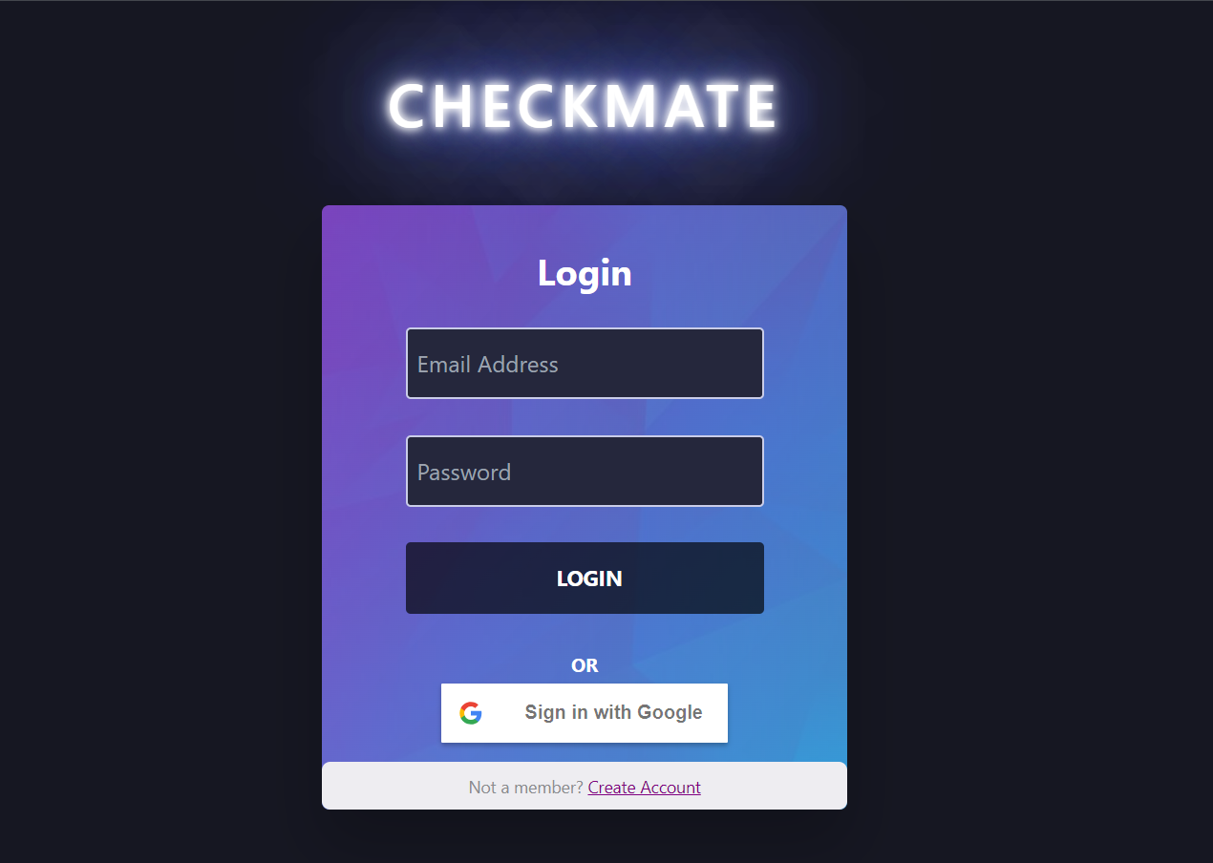

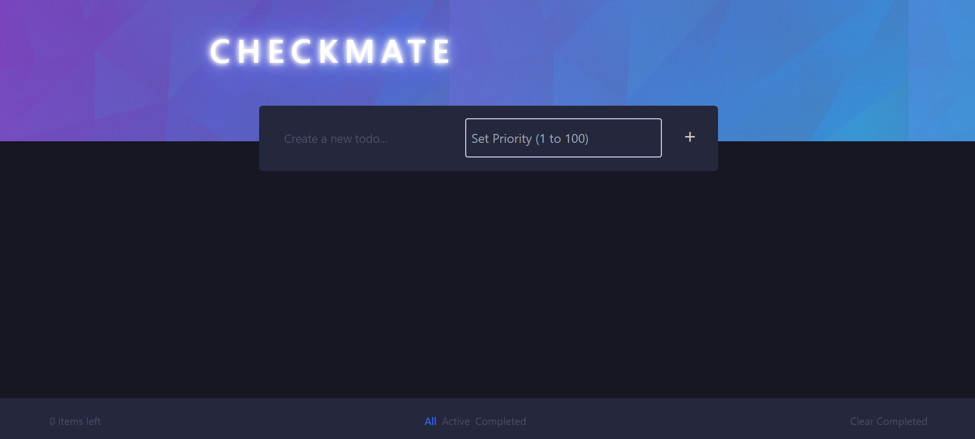

**Chapter 4 Summary**

Chapter 4 of the project focuses on the implementation and testing of CheckMate's proposed system model. The system model was realized through frontend development using React.js and CSS for styling, while backend services were managed with Firebase. Authentication, real-time database management with Firestore, and hosting on Firebase Hosting were key components. The system was designed for scalability, seamless integration, and optimized user experience. Functions implemented included task display, addition, preferences, user authentication, navigation, CRUD operations, and data security measures. A test plan was devised covering frontend design, login/register validation, authentication, task operations, and data storage, ensuring the system's functionality and reliability.

**Chapter 5**

**Conclusion and Further Work**

*This chapter presents……………………*

*5.1 Conclusion and Discussion*

*5.2 Scope for Future Work*

**5.1 Conclusion and Discussion**

After extensive development and testing of the CheckMate todo list app, several key conclusions have been drawn:

CheckMate successfully addresses the challenges faced by individuals and teams in managing tasks effectively. Its user-friendly interface and efficient functionalities, such as task organization, prioritization, and real-time updates, have been well-received by users and testers alike.

The integration of Firebase for backend services, including authentication, data storage, and real-time updates, has significantly contributed to CheckMate's scalability, reliability, and security. This integration ensures that user data is protected and accessible across devices seamlessly.

Additionally, leveraging React.js for frontend development has resulted in a responsive, intuitive, and visually appealing user experience. The use of modern technologies like React.js and Firebase has enhanced the overall usability and performance of CheckMate.

Key Conclusions:

CheckMate effectively streamlines task management, leading to improved productivity and organization.

User feedback and testing have validated the usability and effectiveness of CheckMate's features and functionalities.

Integration with Firebase backend services ensures scalability, real-time updates, and robust data security.

The use of React.js enhances the user experience, making CheckMate intuitive and visually appealing.

**5.2 Scope for Future Work**

Looking forward, there are several areas where CheckMate can be further developed and enhanced:

**Integration with Productivity Tools:** Explore integration with calendars, reminders, and collaboration tools to offer users a comprehensive task management experience.

**Advanced Analytics:** Implement advanced task analytics and reporting features to provide users with insights into their task completion patterns, productivity metrics, and performance trends.

**User Interface Improvements:** Continuously improve the user interface and experience based on ongoing user feedback and usability testing, ensuring CheckMate remains intuitive and appealing.

**Mobile Application Development:** Expand platform compatibility by developing native mobile applications for iOS and Android, allowing users to access CheckMate seamlessly on their mobile devices.

**Machine Learning Integration:** Utilize machine learning algorithms for intelligent task prioritization, automated task suggestions, and personalized task management recommendations based on user behavior and preferences.

These future enhancements and developments will further enhance CheckMate's capabilities, usability, and value proposition for users, ensuring it remains a cutting-edge and indispensable tool for effective task management.